**Franklyn Gonzalez**

**Part I**

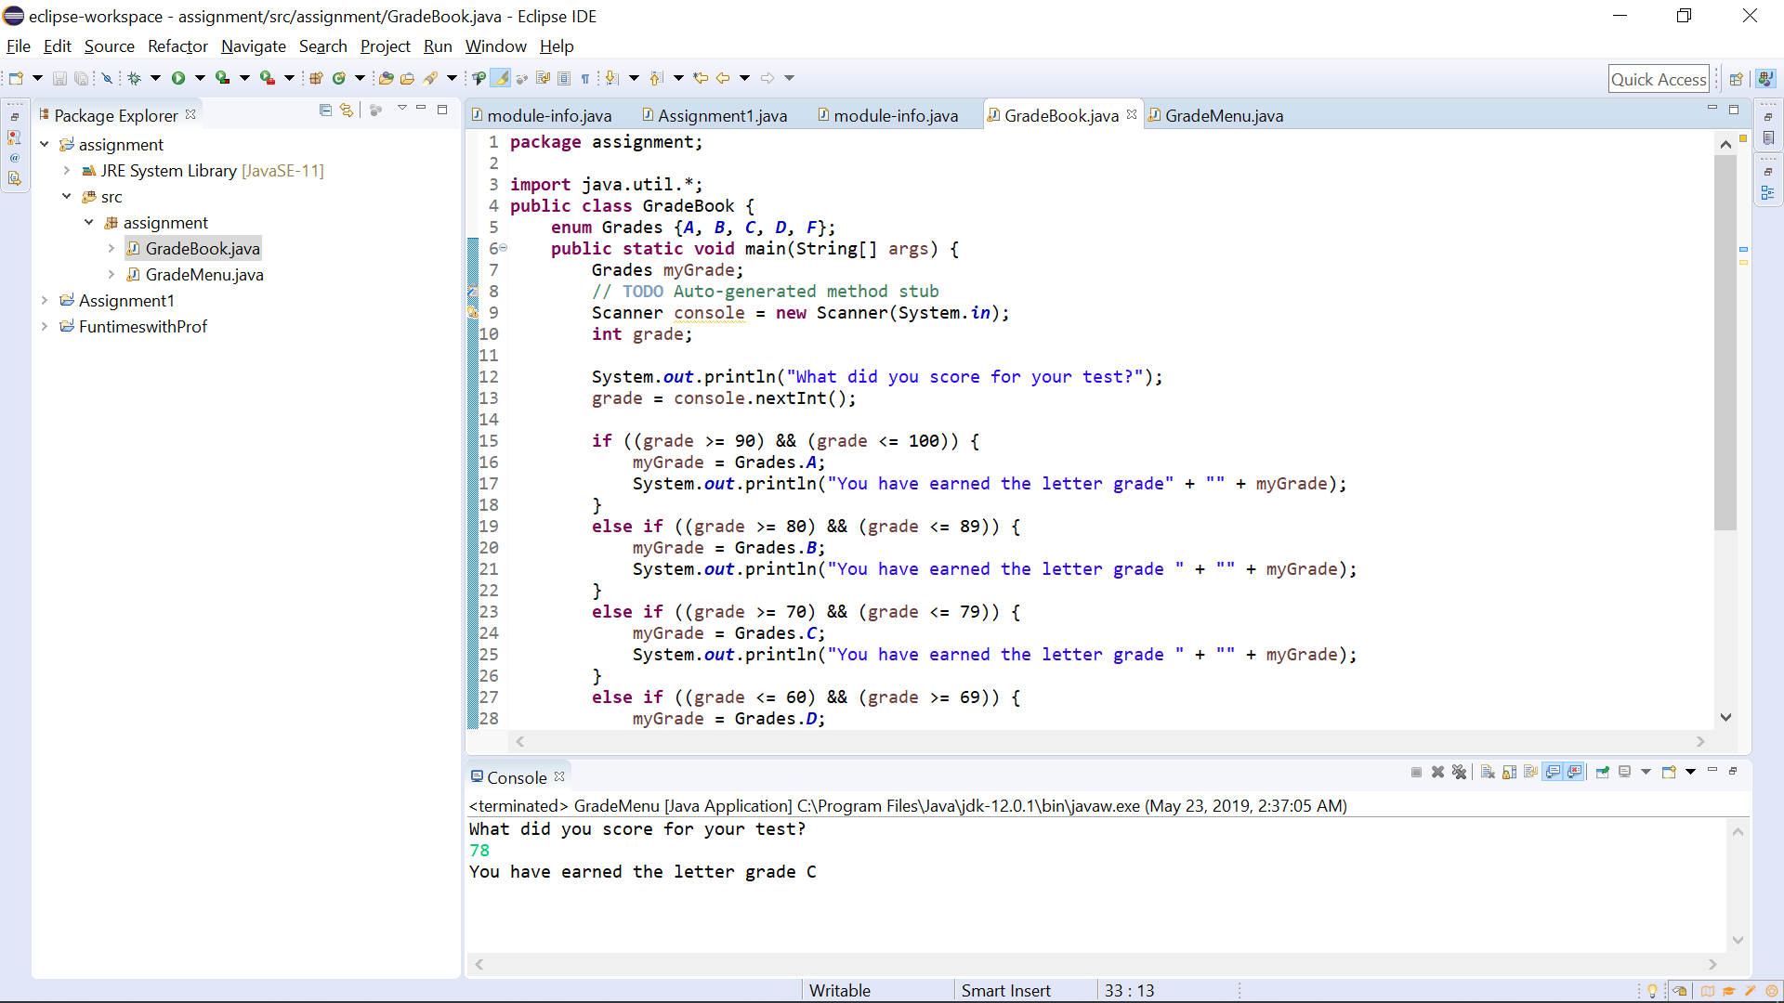

**package** assignment;

**import** java.util.*;

**public** **class** GradeBook {

**enum** Grades {***A***, ***B***, ***C***, ***D***, ***F***};

**public** **static** **void** main(String[] args) {

Grades myGrade;

// **TODO** Auto-generated method stub

Scanner console = **new** Scanner(System.***in***);

**int** grade;

System.***out***.println("What did you score for your test?");

grade = console.nextInt();

**if** ((grade >= 90) && (grade <= 100)) {

myGrade = Grades.***A***;

System.***out***.println("You have earned the letter grade" + "" + myGrade);

}

**else** **if** ((grade >= 80) && (grade <= 89)) {

myGrade = Grades.***B***;

System.***out***.println("You have earned the letter grade " + "" + myGrade);

}

**else** **if** ((grade >= 70) && (grade <= 79)) {

myGrade = Grades.***C***;

System.***out***.println("You have earned the letter grade " + "" + myGrade);

}

**else** **if** ((grade <= 60) && (grade >= 69)) {

myGrade = Grades.***D***;

System.***out***.println("You have earned the letter grade " + "" + myGrade);

}

**else** **if** ((grade <= 59) && (grade >= 0)) {

myGrade = Grades.***F***;

System.***out***.println("You have earned the letter grade " + "" + myGrade);

}

**else** {

System.***out***.println("Error! Invalid grade. Please try again.");

}

}

}

**Part II**

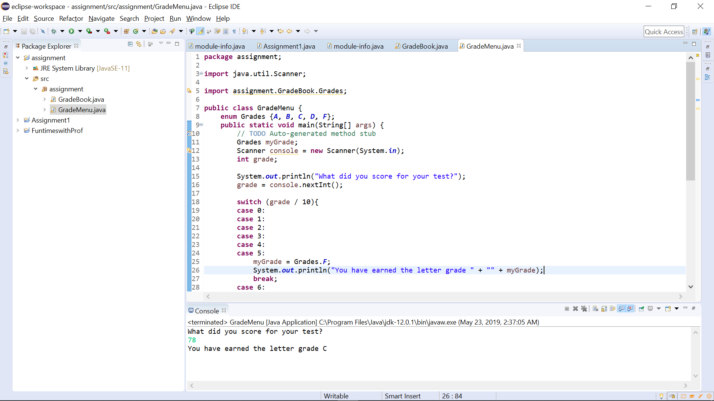

**package** assignment;

**import** java.util.Scanner;

**import** assignment.GradeBook.Grades;

**public** **class** GradeMenu {

**enum** Grades {***A***, ***B***, ***C***, ***D***, ***F***};

**public** **static** **void** main(String[] args) {

// **TODO** Auto-generated method stub

Grades myGrade;

Scanner console = **new** Scanner(System.***in***);

**int** grade;

System.***out***.println("What did you score for your test?");

grade = console.nextInt();

**switch** (grade / 10){

**case** 0:

**case** 1:

**case** 2:

**case** 3:

**case** 4:

**case** 5:

myGrade = Grades.***F***;

System.***out***.println("You have earned the letter grade " + "" + myGrade);

**break**;

**case** 6:

myGrade = Grades.***D***;

System.***out***.println("You have earned the letter grade " + "" + myGrade);

**break**;

**case** 7:

myGrade = Grades.***C***;

System.***out***.println("You have earned the letter grade " + "" + myGrade);

**break**;

**case** 8:

myGrade = Grades.***B***;

System.***out***.println("You have earned the letter grade " + "" + myGrade);

**break**;

**case** 9:

**case** 10:

myGrade = Grades.***A***;

System.***out***.println("You have earned the letter grade " + "" + myGrade);

**break**;

**default**:

System.***out***.println("Error! Invalid grade. Please try again.");

}

}

}

**Part III**

The reason why if-else-if technique is better than the if statements is because the branch sequence would only select one of the if-else-if statements. The if statements are selected one at a time, creating poor program efficiency. The code is much cleaner while it is written in if-else-if statements, thus making if-else-if statements the perferred choice.

**Part IV**

The class *String* doesn’t provide this option. In this case, once they are created, they cannot be changed. If you write another statement (“Hello!”) under the same reference variable such as *str*, the statement would cause the system to allocate memory space to store the string (“Hello!).

The address of the allocated memory space will be different from the first statement. The first statement could be 2499 and the second statement could be 3499. If no other *String* variable refers to the first statement, the Java system reclaims this memory space for later use. Which is called garbage collection. This has definitely helped me realize how *String* objects make memory space costly, on the IDE.